13 May 2017
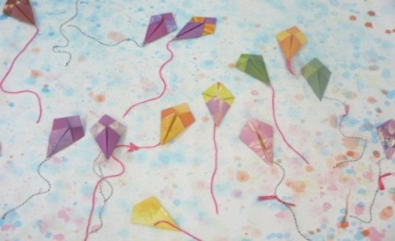

Dear Parents/Carers
Sheet Primary School Community Art Gallery 2017
At Sheet Primary School we value the importance of creativity and enjoy celebrating the inspiring talents of both our children and our local community.
With this in mind, we would like to invite all parents, grandparents, siblings, aunts, uncles, friends and neighbours of the community to take part in our bi-annual art gallery held at Sheet Primary School on Friday 16th June to Saturday 17th June. The event this year is also going to include the exciting revealing of our incredible school bird sculpture which has been a yearlong collaboration incorporating the ideas and practical work from our children with the local artist Cara Wassenberg.
The gallery is open to all budding amateur or professional artists, crafters, potters, sculptors, textile sewers and designers. The community art work will be exhibited alongside the children’s work in a gallery environment. This event is very popular and provides our children the opportunity to become art critics for the day when visiting the gallery in their classes on the Friday. Parents will be able to view the exhibits after school on the Friday and the gallery will be open to the general public on the Saturday. Further details will be circulated closer to the time.
As a whole school we have been focussing on STEAM learning this year and the gallery will be great opportunity to showcase some of our children’s wonderful ideas.
We welcome contributions from all members of the community so if you are interested in taking part, or if you know someone who would like to show their work to help inspire the children, please complete the slip below. We will then contact you closer to the event with drop off times and entry requirements.
Many thanks

Mrs Deuble

Sheet Primary School Community Art Gallery 2017

Name ……………………………………………………………………………………………………………..……………………………………..

Relationship to child (if applicable)…………………………….………………………………………………………………………….

Address………………………………………………………………………………………………………………………………………………….………………

………………………………………………………………………………………………………………………………………………………………………………………..

………………………………………………………………………………………………………………………………………………………………………………………..

Telephone number…………………………………………………………………………………………………………………………………..

*Please provide a brief description of the work you wish to display:

