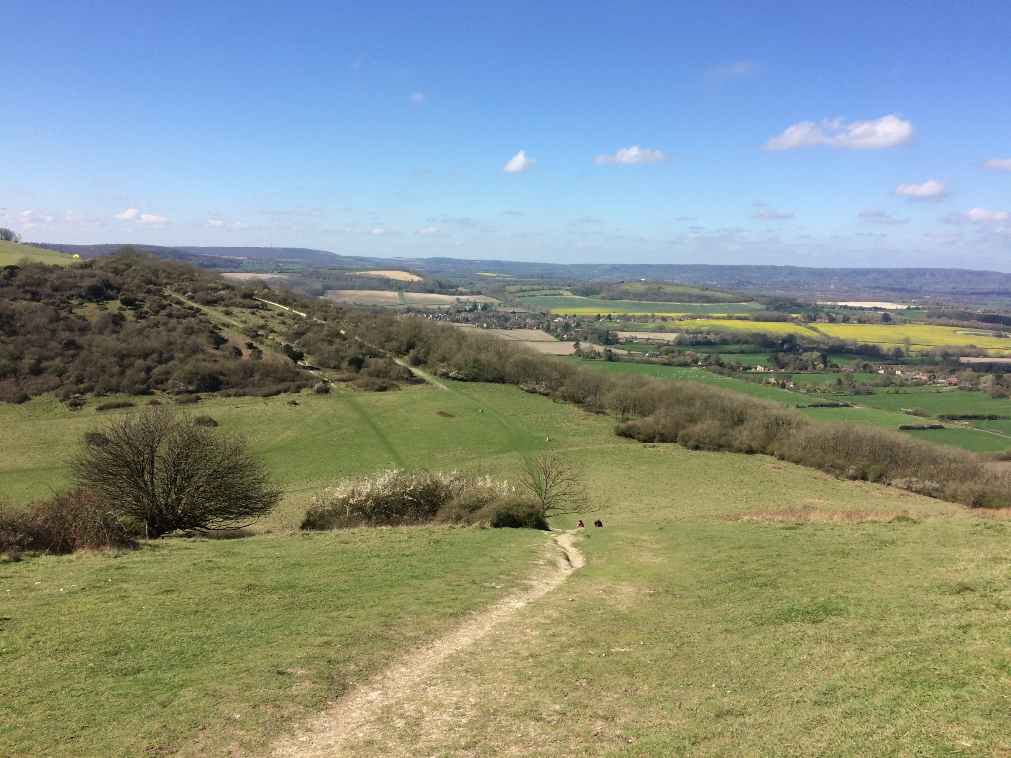
SHEET PARISH COUNCIL
ANNUAL PARISH
ASSEMBLY
THURSDAY, 10TH MAY
SHEET VILLAGE HALL- 7.00 P.M.

Laura Deane, SDNPA Ranger, will talk about project works in the local area
To be followed by refreshments and an up-date on Parish Council activities 2017-18 – All welcome!

